As we replicate the implications of the Isolation levels, we will use the Member.memberNumber as the field that displays consistency/inconsistency

**Isolation Level:** ReadUnCommitted

**DIRTY READ**

Set memberNumber to 1.

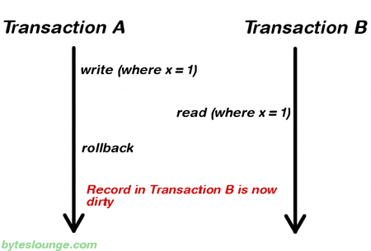

Start Transaction A [in TransactionService], set memberNumber to 12

Start **NEW Transaction B** [in ReadUnCommittedService] read memberNumber = 12 ***Dirty

END Transaction B

ROLLBACK Transaction A

read memberNumber = 1

**Isolation Level:** ReadCommitted

**NO DIRTY READ**

Start **Transaction A** [in TransactionService], set memberNumber to 12

Start **NEW** **Transaction B** [in ReadCommittedService] read memberNumber = 1 *** GOOD DATA

END Transaction B

ROLLBACK Transaction A

read memberNumber = 1 for Start of Next test

**Isolation Level:** ReadCommitted

**NON REPEATABLE READ**

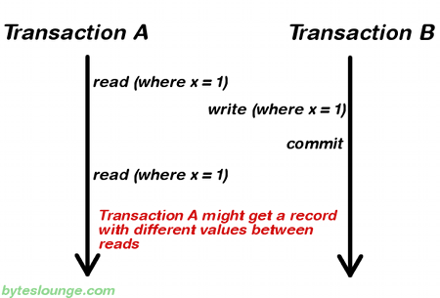

Start **Transaction A** [in ReadCommittedService], read memberNumber = 1

Start **NEW** **Transaction B** [in TransactionService] set memberNumber = 44 ; WRITE

END Transaction B

**Transaction A** [in ReadCommittedService], read memberNumber = 44 ** should be 1

END Transaction A

**NOTE when we read memberNumber, it is NOW == 44 this is what we use in NEXT “Test”**

**Isolation Level:** Repeatable_Read

**REPEATABLE READ**

Start **Transaction A** [in RepeatableReadService], read memberNumber = 44

Start **NEW** **Transaction B** [in TransactionService] set memberNumber = 100

END Transaction B

**Transaction A** [in RepeatableReadService], read memberNumber = 44 ** GOOD DATA

END Transaction A

read memberNumber = 100 unused in Next test

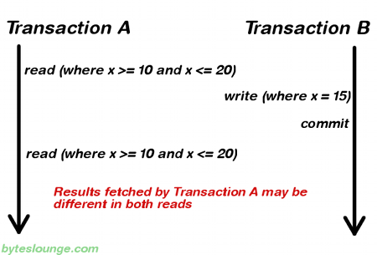

**NOTE Produced PHANTOM READ for READ_COMMITTED but could NOT for REPEATABLE_READ**

**To run - Change isolation level in** RepeatableReadServiceImpl

**Isolation Level:** repeatable_read

**PHANTOM READ**

Start **Transaction A** [in RepeatableReadService], READ x>=1 and <= 5; Member[x=4] Name: Bill Bixby

Start **NEW** **Transaction B** [in TransactionService] update member[x=4], Member Name: Jimmy Durante

END Transaction B

**Transaction A** [in RepeatableReadService], Member Name[x=4]: Jimmy Durante

This is a FAILURE [with READ_COMMITTED]

END Transaction A

------------- Repeatable Read - Phantom read -------------------

Transaction Service BEFORE Phantom Modify Member Name: Jim Dandy

Transaction Service Phantom Member Name: Jimmy Durante

Transaction Service AFTER Phantom Modify Member Name: Jim Dandy